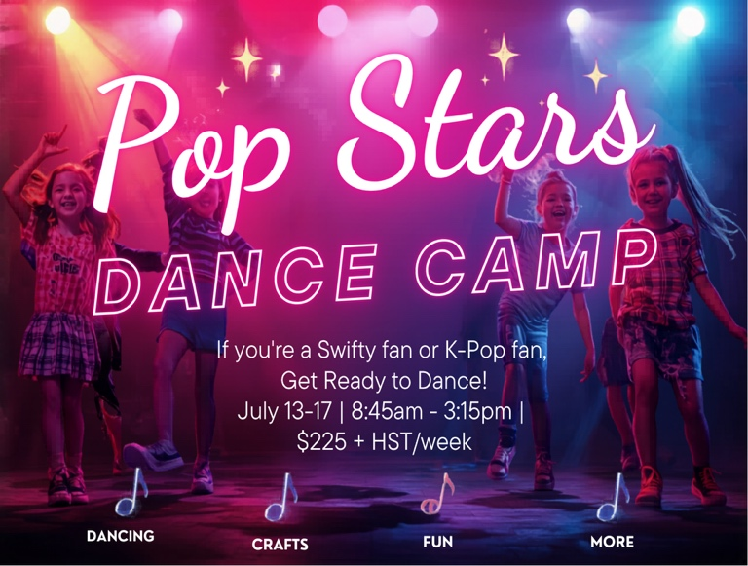
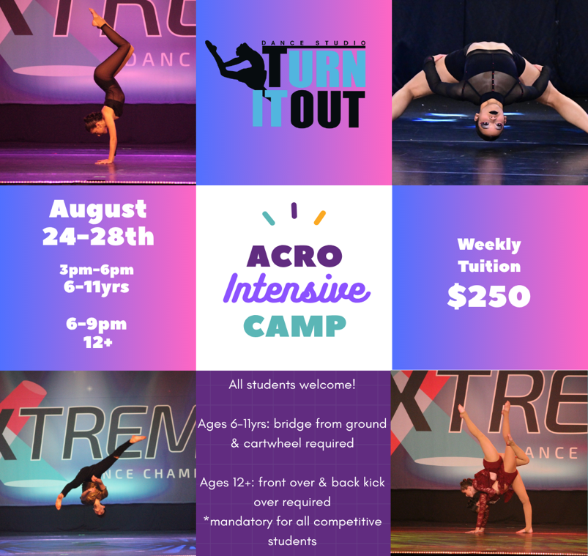
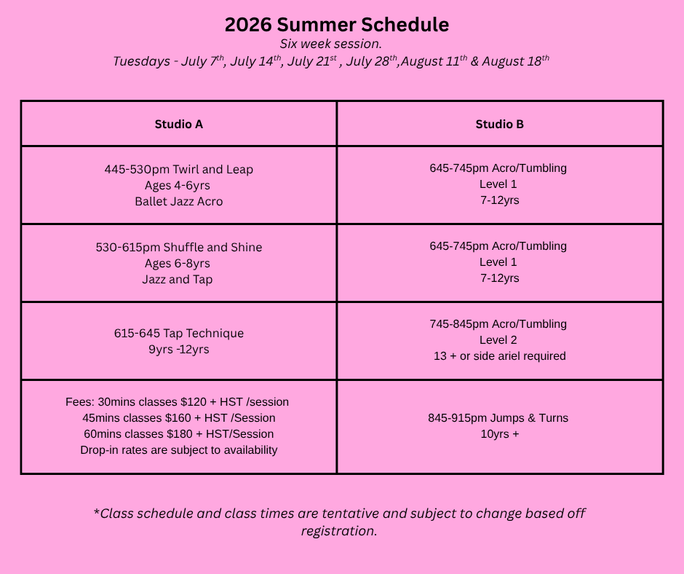
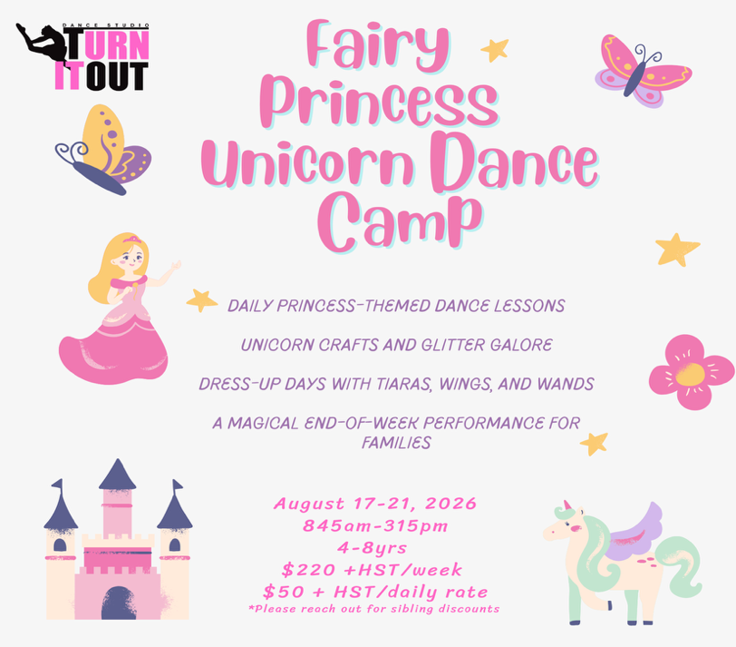

☀️ Make This Summer One to Remember! ☀️
Whether your dancer wants to train all summer long or enjoy a week of fun, we've got something for everyone!
✨ Join our 6-Week Summer Session and keep your skills growing.
🦄 Dance, create, and imagine at one of our exciting Summer Camps.
🎤 Who doesn't love POP STARS? Our themed camps are packed with dancing, games, crafts, and unforgettable memories!
Can't commit to all 6 weeks? No problem! Drop-in classes are available (pending availability).
Need flexibility? Daily camp rates are also available based on interest.
Spaces are limited—register today and let's make this your best summer yet!

SUMMER SESSION
2026
Register Today!

